Project Report: Analysis of YouTube Trending Videos

1. Introduction
With the rapid growth of online video platforms, understanding user engagement and content trends has become increasingly important. YouTube, being one of the largest video-sharing platforms, provides valuable data on how different types of content perform across regions.
This project focuses on analyzing YouTube trending videos in Canada using Python-based data analysis techniques. By studying views, likes, and content categories, the project aims to extract meaningful insights about audience preferences and engagement patterns.

2. Objectives
The main objectives of this project are:
- To perform exploratory data analysis on YouTube trending video data
- To identify which content categories trend most frequently
- To analyze the relationship between views and likes
- To visualize insights using Python libraries
- To demonstrate practical data analysis skills using real-world data

3. Dataset Description
The dataset used in this project is the YouTube Trending Videos Dataset for Canada.

Dataset Summary
Attribute | Value
File name | CAvideos.csv
Number of rows | 40,881
Number of columns | 16
Data type | Structured CSV

Important Columns
Column Name | Description
video_id | Unique ID of the video
title | Title of the video
category_id | Category assigned to the video
views | Number of views
likes | Number of likes
dislikes | Number of dislikes
comment_count | Number of comments
trending_date | Date when the video trended
video_error_or_removed | Indicates invalid or removed videos

4. Tools & Technologies Used
Tool | Purpose
Python | Core programming language
Pandas | Data loading, cleaning, manipulation
Matplotlib | Basic plotting
Seaborn | Advanced data visualization
VS Code | Development environment

5. Methodology and Data Cleaning
Before analysis, the data underwent a cleaning process using Python (Pandas):
- Filtering: Removed videos that were marked as "removed" or had errors.
- Type Conversion: Engagement metrics (views, likes, dislikes, and comments) were converted to numeric formats to ensure accurate calculations.
- Library Stack: Utilized Pandas for data manipulation, and Seaborn and Matplotlib for visualization.
6. Findings and Visualizations
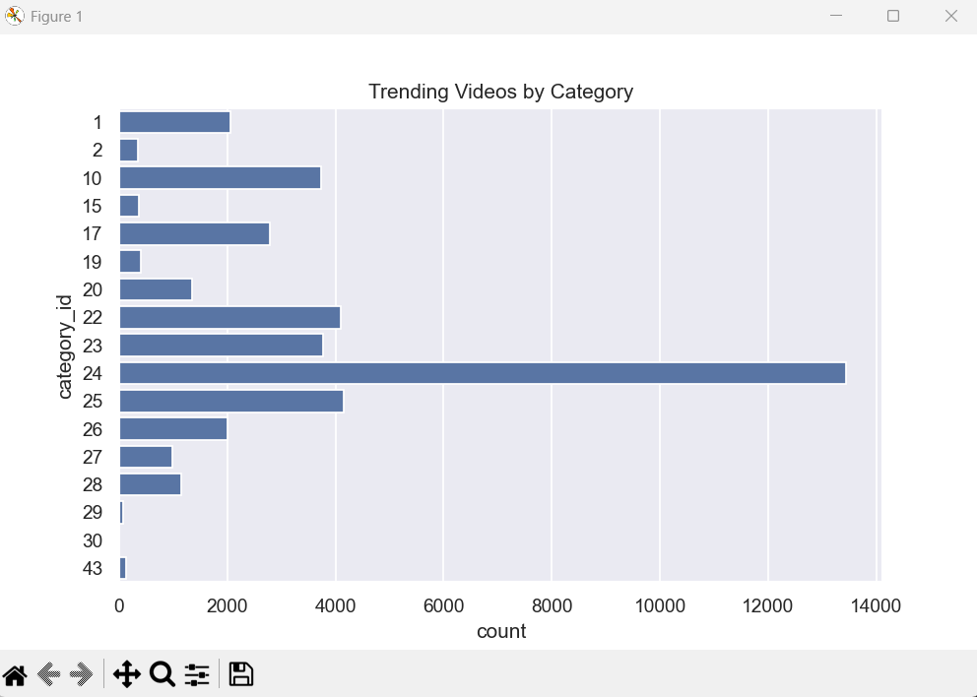
A. Distribution of Trending Videos by Category

The bar chart above shows the frequency of videos appearing in the trending list based on their category_id.
Observation:
- Category 24 (Entertainment) is significantly more frequent than any other category, suggesting that entertainment content dominates the trending algorithm in this region.
- Categories 10 (Music), 22 (People & Blogs), and 25 (News & Politics) also show high trending frequency.

Category Distribution (Optional but Strong)
Category ID | Number of Trending Videos
24 | Highest
22 | High
10 | Moderate
Others | Lower

B. Correlation Between Views and Likes
To understand audience behaviour, we plotted the relationship between the total number of views and the number of likes received.

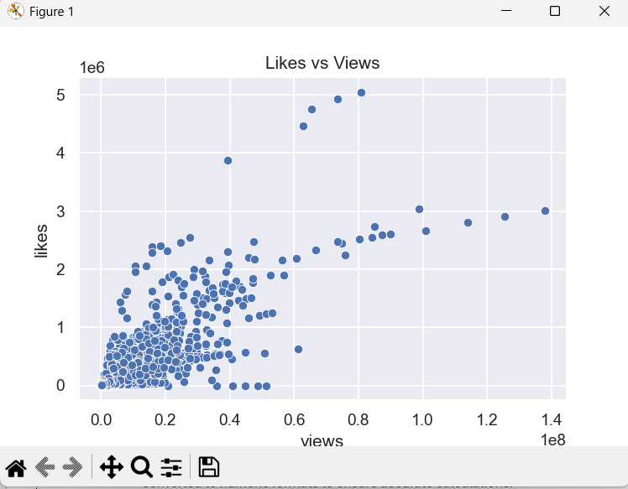

Observation:
- There is a clear positive correlation between views and likes.
- As views increase, likes generally increase linearly, though some viral outliers achieve significantly higher engagement than the average video.

7. Top Performing Content
Top 5 Most Viewed Trending Videos
The top 5 videos were identified by sorting the dataset based on views.

Sno. | Video_id | description
1 | n1WpP7iowLc | Eminem's new track Walk on Water ft. Beyonce©
2 | 0dBIkQ4Mz1M | Still got a lot of packages. Probably will last
3 | 5qpjK5DgCt4 ... | - WATCH MY PREVIOUS VIDEO â¶ \n\subscribe âº ...
4 | d380meD0W0M ... | know it's been a while since we did this show.
5 | 2Vv-BfVoq4g ... | §: https://ad.gt/yt-perfect\nð°: https://...

Observation:
- Trending videos can reach extremely high view counts
- Popularity is often driven by viral or entertainment-focused content

8. Key Insights
- Certain categories dominate YouTube’s trending section
- Views and likes are strongly correlated
- Some videos achieve high engagement without extreme view counts
- Trending content is not evenly distributed across categories

9. Conclusion
This project successfully demonstrates how Python-based data visualization can be used to analyze social media trends. By exploring YouTube trending data, meaningful insights were derived regarding content popularity and user engagement.
The project highlights the importance of data cleaning, exploratory data analysis, and visualization in understanding real-world datasets.

